Imagine....

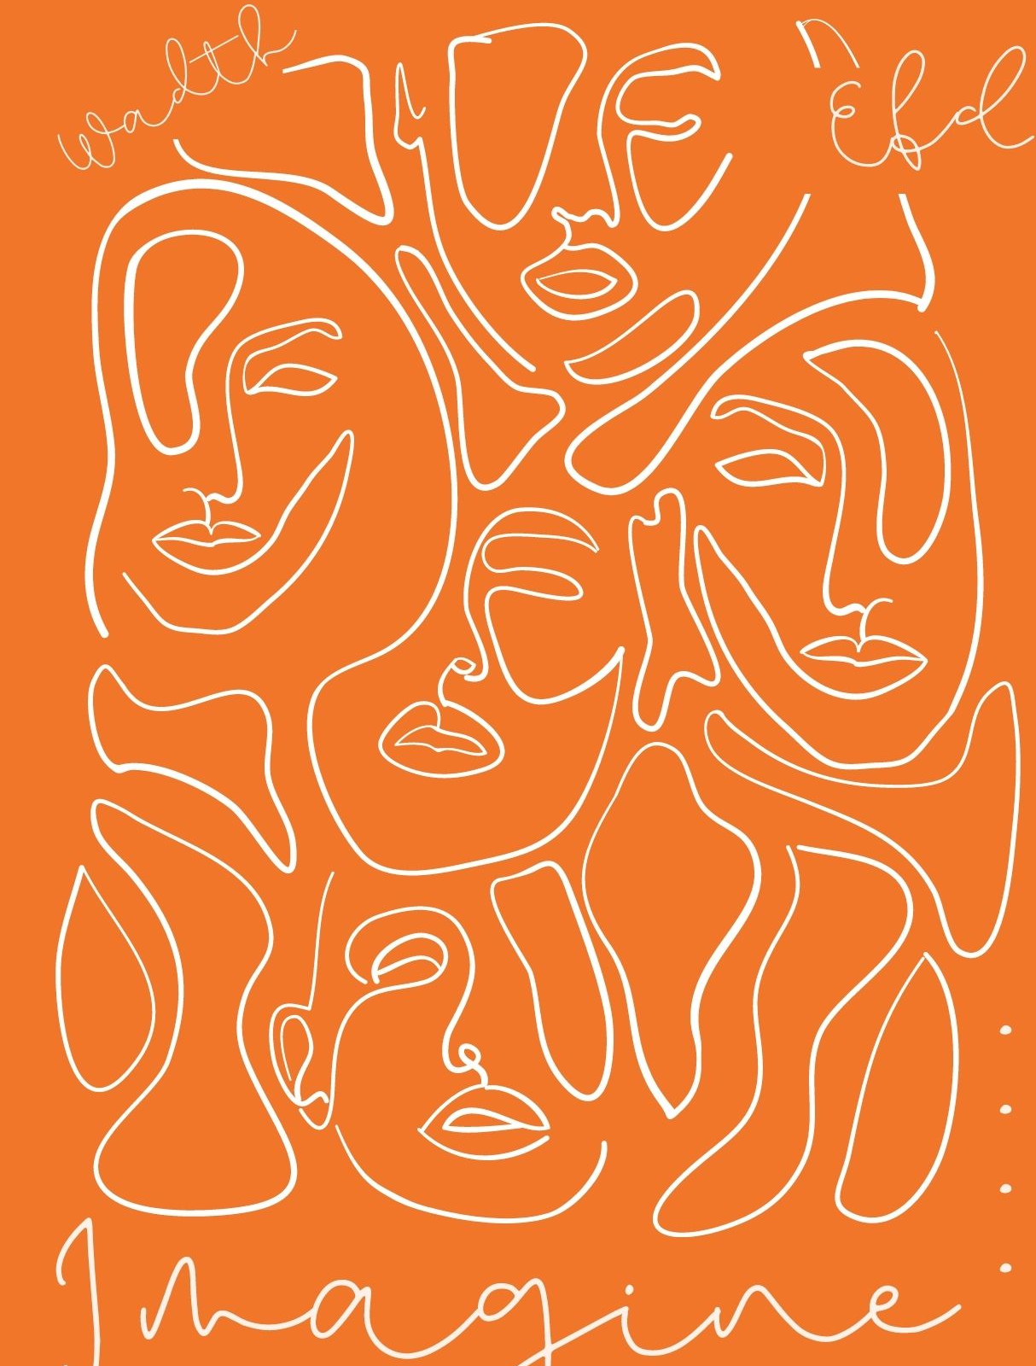
presenting at the International Dramatherapy Conference in The Netherlands

With the power to imagine, we create spacious narratives. Imagination can take us to places and paint the world in the colours we want. It makes us believe that things can be different. Imagination helps us to build curiosity, to acquire experience and knowledge about the world, to better understand another person's perspective, to adapt with agility, to flourish through adversity, to ignite motivation, to creatively connect, innovate and overcome challenges. Through imagination we conceive and interact with artistic works. Imagination has the extraordinary capacity to dimensionalise and shape our past, present and future reality, give meaning and hope. It is an area where it is possible to be free. But imagination that is out of control may lead to helplessness, hopelessness, anxiety, suspicion, conspiracy or (territorial-) aggression. An imagination that is better directed may help contain them.

This International Dramatherapy Conference is the first collaboration between the European Federation of Dramatherapy (EFD) and the World Alliance of Dramatherapy (WADth). On the 5th and 6th of May 2023 in Amersfoort in the Netherlands, we want to explore the power, the depth, the healing or destructive aspects and everything that comes with the (im)possibility to imagine. We are curious about your research and professional experiences on the conception, nature and use of imagination in relation to dramatherapy or community-based theatre.

We invite you to respond to this call to ‘Imagine....’ with a conference proposal, containing ideas for a workshop or paper presentation. Please send your proposal in Word or PDF by using the enclosed proposal format before the 1st of December 2022 to the following mail address: efdnetherlands@gmail.com.

It will then be forwarded to the selection committee to be appraised. You will be notified by the end of January 2023.

Imagine....,

The organising committee,
Commissioned by the EFD and the Dutch Dramatherapy Association (NVDT). In collaboration with WADth.

Karin van der Wiel,
Denise de Jong van Lier,
Jeroen Ward,
Margot Lambregts,
Irene de Bel,
Marc Willemsen
1a. Personal Details workshop facilitator or presenter
First name |  | Surname/Family name
Full Postal Address |  | Email address
Country |  | Telephone number
Profession | Place of work |  | Association
1b. Personal details workshop co-facilitator or co-presenter (if applicable)
First name |  | Surname/Family name
Profession | Place of work |  | Association
2. Workshop or presentation:
- 2-hour workshop
- 30 minutes paper presentation
3. Title of your workshop or presentation
4. Abstract (300 words max)
5a. Short biography workshop facilitator or presenter (150 words max.)
5b. If applicable short biography workshop co-facilitator or co-presenter (150 words max.)
6. Recent publications and conference presentations workshop facilitators or presenters
7. Needed equipment
8. Maximum number of participants when a workshop is facilitated (preferably 25-30)
By sending this application I - or in case of a co-facilitator/co-presenter - we agree that my or our personal details can be used for communication about the application and will not be used in any other way. I or we agree that my or our name in combination with information about the workshop or presentation, the given biography or biographies and publications and presentations can be used for the conference program and communication about the program. I or we agree that when we give a presentation (not applicable for workshops), the presentation can be streamed to online participants of the conference.

Date of application:

International Dramatherapy Conference in Amersfoort in The Netherlands, 5 & 6 May 2023

